**Novel Cell Counting Algorithm and Image Processing for Cells *in vitro***

Daniel Amante, Jarel Cohen, Robert MacGregor, Ashutosh Priyadarshy

University of Virginia Biomedical Engineering Department, School of Engineering and Applied Science, 415 Lane Road, Charlottesville, VA 22908

*(received 13 May 2011)*

**Abstract**

**Introduction**

Many different methods currently exist to count cells in culture. These methods have been developed based on the distinct parameters of culture conditions and varying growth of the cells. Cells that often require counting include but are not limited to: erythrocytes, leukocytes, neurons, bacteria cultures, and cells from known cell lines (i.e. chinese hamster ovary cells and bovine aortic endothelial cells). When cells grow in vitro, they vary in the method of that growth. Some will adhere to the dish in which they have begun to grow, eventually reaching an optimal density known as confluence. Others will grow in multiple layers. The cells are used for different forms of research, some in which they cannot be disturbed physically. This adds complexity to the cell counting problem. Because of the inherent variability for the need to count cells in cultures, many marginally successful products have entered the market space. Some of these products, with both their advantages and disadvantages, are addressed below.

*Visualization by Eye*

The earliest form of cell counting is by pure visualization. This basic method is usually conducted by taking a microscope image of existing cultured cells or those fixed to a plate, and then physically counting the cells. This method is the most accurate of all cell counting techniques for several reasons. First, the cells can remain in culture and a cell count can be obtained for each stage of the plate’s confluency of cells. Second, since the investigator is viewing the cells, an accurate distinction can be made by those cells that are healthy and those that are not viable. Third, the investigator is also able to determine regions where cells overlap on the culture dish, and make definitive conclusions as to the number of existing cells. However, the major disadvantage of this approach is that it is the slowest of all possible cell counting modalities, and is highly dependent on the accuracy of the user.

*Hemocytometer*

The hemocytometer improves upon the ease of visual cell counting by providing protocols and a distinct apparatus for counting a cell sample. The hemocytometer contains a laser-etched grid of perpendicular lines mounted on a glass microscope slide. A specific volume of a solution containing cells is placed in the hemocytometer, and the number of cells is counted in several grids. This method can be used to estimate the total number of cells in solution if the volume is known. There are some potential pitfalls to this method however. First, it is necessary to remove some cells from culture in this analysis, something that isn’t always possible in certain experiments. Also, uneven mixing can significantly affect the density calculations. This can be minimized by counting cells in a number of grid points on the slide.

*Machines*

The Countess Automated Cell Counter from Invitrogen is a benchtop automated cell counter. The machine not only performs cell counting, but viability and cell volume calculations. Its touch screen display allows data to be transferred to a USB drive and its relatively small size does not use much bench space. The Countess can measure cell concentrations from 104 to 107 cells per mL, with a mean cell diameter from 5 to 60 µm. To use the Countess, 10 µL of sample cell solution must be isolated and combined with 10 µL of trypan blue stain. A total of 10 µL of this solution is then inserted into the disposable cell counting chamber slide. By first focusing the image on the display screen of the machine, the cells are then counted and the following data is collected: total count, live count, dead count, and mean diameter. While the Countess is a quick and automated means to count cells, there are a couple negative features. First, cells must be removed from the environment from which they were growing, which is detrimental in some experiment set-ups. Second, since the counting slides are disposable, there is a large cost in performing frequent counts. Third, the concentration range that the machine can accurately quantify may limit its effectiveness in a particular study based on the type of cell and confluency of the sample.

The NucleoCounter is an automated cell counting machine that is used primarily for mammalian cultures. This device combines the traditional approach of using a hemocytometer and microscope with fluorescence microscopy technology to determine cell concentration. The NucleoCounter uses disposable cassettes that are precoated with a fluorescent dye, propidium iodide (PI), which stains for the cells nuclei. With this approach, the system determines cell concentration without regard to cell morphology or size, increasing its ability to count all cell types. The cell samples are pretreated with lysis and stabilization buffers that dissolve cell aggregates and lyse cell membranes. The sample is then loaded into a disposable cassette and placed in the machine for 30 seconds while the nuclei are counted in the solution. While nuclei counting is accurate and fast, many researchers cannot use this machine because it requires their samples to be lysed. This would not be an effective cell counting mechanism for experiments that use a small number of highly specific cells. Furthermore, these cells would have to be removed from their cultured environment, causing further variations.

The Scepter 2.0 is a new Millipore technology that brings accurate cell counting to the culture hood. The Scepter is an automated cell counting device that is built into a mechanical pipette. The Scepter cytometer provides users with detailed histograms and numerical statistics and capabilities of accurately counting every cell in the sample, including those with diameters less than 6 µm. This cell counter uses the Coulter principle of impedance-based particle detection to accurately count every cell in the sample. First, a specific volume of cell suspension is drawn into the Sceptor sensor. Second, the cells are able to flow through the aperture in the sensor, which increases the resistance and voltage of the inner circuit. The voltage changes are recorded as spikes with each passing cell, which are used to give a final cell count of the sample. The Scepter 2.0 allows investigators to count cells directly under the culture hood, but also requires them to disturb their cell cultures in ways that can disrupt ideal conditions.

While each of these cell counting apertures are widely used in the scientific community, they all require the cells to be removed from their culture conditions. In many experiments, this procedure is appropriate and will not negatively affect the outcome of the study. However, for those investigators that culture cells which cannot be disturbed or removed from their cell plate surface, these machines are not an option.

*Estimations (ImageJ)*

More recently with advancements in computers, programmers have begun to create algorithms to replicate the ability of the human eye to identify cells while minimizing the possible negatives of the long counting time and inaccuracy. ImageJ, an imagine processing program used in conjunction with high-powered microscopes, has programs that count cells in an image. Once the user has acquired a biological experimental image, the automatic particle analysis requires the image to be a binary image (black or white). In order for the program to function properly, it needs to know exactly where the edges are to perform morphology measurements. The user can set a threshold range, changing all those pixels with values within the range to black and the pixels with values outside of the range to white. Once this is completed, the image is filtered and the particles are counted. The advantage of using this cell counting function in ImageJ is that the cell sample can remain in culture as long as a clear image can be acquired. However, the major problem with this program is with its inaccuracies in determining total cell count with cell cultures of high confluency. Since the program recognizes distinct edges of cell morphology change, the cell samples that are confluent and contain overlapping cells cause cell count discrepancies.

*Challenges associated with cell counting*

 While the notion of counting cells sounds relatively simple, computers have historically struggled to accomplish the task. The issues stem from a variety of circumstances that severely limit the method by which cells can be counted. These issues are both biological, including the closely packed cells resulting from confluence, the nature of cell biology and the existence of organelles, and the random orientation of adhered cells, as well as imaging issues, including resolution, lack of apparent cell boundaries, and speckling.

The primary challenge results from confluence. Confluence results in vitro when cells are allowed to divide until they cover the entire available surface, for instance a petri dish. The cells are forced into such close contact that no space exists between them; that is to say, one cellular membrane will appear to divide two cells, rather than a membrane, empty space, and a second membrane barrier. This phenomenon severely inhibits the technique used by the popular cell-counting program *ImageJ* which functions by tracing the outer-contours of cell. In this situation, when confronted with abutting cell membranes, the contour-trace may err and follow the wrong path by tracing the outside of two cells. Figure (XX) at right, for instances, displays three distinct cells. The two cells to the right, however, are counted by the program as one. As the software traces the bottommost cell and reaches the point indicated by the arrow, the trace moves upwards rather than to the right. *ImageJ*, due to confluence, may thus underestimate the number of cells present in a sample.

http://www.google.com/imgres?imgurl=http://www.assaysoft.com/gallery/03CellCounting/cellCounting_files/image014.jpg&imgrefurl=http://www.assaysoft.com/gallery/03CellCounting/cellCounting.htm&usg=__pTksL6e6NVck6h7JTqr4-aUe5uo=&h=352&w=624&sz=44&hl=en&star

One possible alternative to *ImageJ* attempted to use the built-in *Matlab* function “bwboundaries” (Moore Neighbor - add)in coordination with thresholding to produce an accurate cell count. This function will highlight and count boundaries (rather than trace), potentially eliminating the double count. A complication in this method arises in the presence of organelles. Cell organelles, the functional bodies within cells, may have membranes of their own and appear to be cells themselves. This problem is small when the predominant organelle is the nucleus, as in Figure (XX). The program counts the nuclei, almost to the exclusion of the whole cell. A few other organelles are counted, producing a slight over count. However, as these cells have only one nucleus each, and as the actual cell exterior is too faint to register, the count is fairly accurate. If the exterior were outlined as well, the parameter ‘noholes’ could be implemented, which would prevent an outline from forming within another outline and ensure that either the nucleus or the whole cell are counted, but not both.

The method breaks down, however, when there exist other, well-defined organelles. Bovine endothelial cells (BECs), are a very popular type for cellular research. Due to the widespread use of these cells in studies, the algorithms in this paper were applied primarily to BECs. Typical BECs, as displayed in the Appendix (figure Xx), contain a series of smaller organelles within the main cell body. The basic bwboundary command, applied with the thresholding, appeared to outline these smaller organelles within the cell and add them to the total cell count, as shown in Figure (XX). The cell count was thus expected to yield a dramatic overestimate. The returned value of 848 objects was nearly a five-fold increase from the hand-counted value of 170 cells.

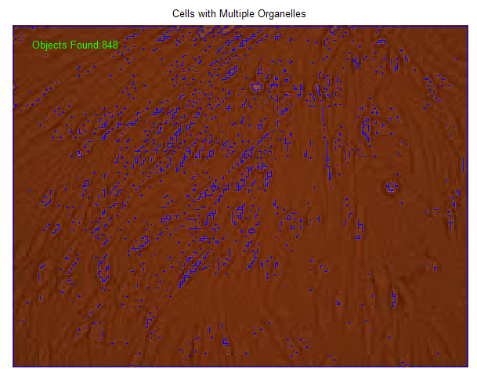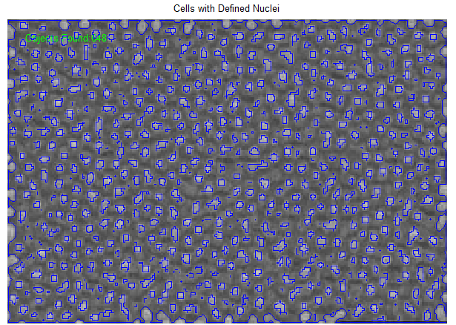

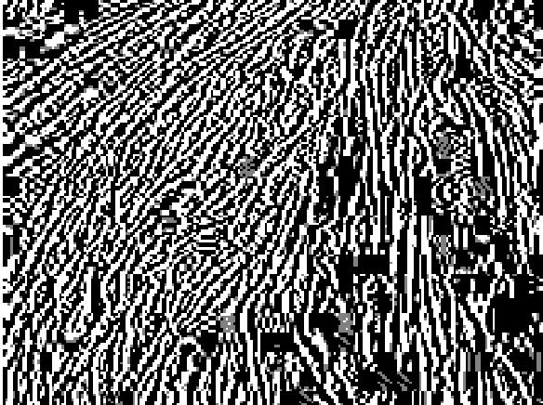 An additional method to resolve cell boundaries in order the facilitate counting involved the use of gradients. Cell boundaries, be they with the background, or else between two confluent cells, represent a location where the pixel values rapidly change. Ideally these large gradient values would provide an adequate parameter to be counted. The presence of organelles, as well as artifacts in the form of specks on the images themselves, rendered the ability of this method to provide a count, however. As shown in Figure (XX), a gradient image of Figure Xx from the appendix, high gradient values corresponded not only with the cell boundaries but with all boundaries. While the gradient method cannot be used to count cells, it does however provide a reasonable overview of the general orientation of cells.

*Published Works*

While the task of efficiently and accurately counting cells in cultures that do not allow for removal from a growth surface remains a challenge, some scientists have been able to use specific cell counting algorithms and image processing techniques to quantify their cell cultures. Markiewicz et. al used Computerized Analysis of Microscopic Images (CAMI) design software to digitally reconstruct the diversiform glands seen in chronic inflammatory gastric mucosa. With CAMI visualization, the group stained the selected cells to recognize the cytoplasmic immunoreactivity. A sequential thresholding algorithm combined with an artificial neural network was used to spot the unstained cells for analysis. This technique was effective in accurately quantifying and reconstructing those cells which had been stained, but faced difficulties due to the inherent analysis of a more spatial distribution of immunostained cytoplasm in contrast to those cells which remained unstained.

Bewes et. al proposed an automated cell colony counting method that was both flexible and capable of providing an ind-depth clonogenic analysis. The group used the full form of the Hough transform, which uses template matching to group pixels into colony candidates. After initial image preparation to define the cell colony, the colony edges were identified by intensity gradient field discrimination. While this approach was effective in identifying colonies with unusual morphology and merged colonies, its computationally intensive step of calculating entries in an accumulator array was not ideal.

Researchers at Harvard Medical School developed an algorithm for automatic cell counting in microwell arrays. Their work, called Arraycount, consists of cell imaging using a fluorescent microscope in microwell arrays. Green and red fluorescent images were extracted and a template-matching algorithm was used to determine local maxima in fluorescence compared to correlation maps. The software they recorded the cell counts for each microwell in the original image. While this method produced automatic counting results only 2.5 to 3% different than manual counting, it does require the cells to be plated in microwells prior to imaging.

Zhou et. al used optical microscopy to produce an effective automated, quantitative analysis system that was used to track, segment, and quantize cell cycle behaviors of a large population of cells nuclei efficiently. Their approach used both the watershed algorithm and adaptive thresholding to segment cell nuclei. The phases of cell nuclei were identified using the Markov model based on the information of time-lapse data. Their results proved successful in analyzing nuclei segmentation and cell phase identification. Other cell segmentation studies used an unitone conversion to obtain a single-channel image with high contrast. From these images, which contained a bimodal distribution due to H&E-stain, a cell-likelihood image was created.

Researchers used human embryonic stem cell (hESC) cultures to identify a fast and consistent method for in situ automated hESC population estimation to quantitatively estimate cell growth. Each cell was fixed and stained for nuclear proteins, and imaged using high-resolution microscopy. Their analysis used a watershed operator to split most physically overlapping nuclei. This manipulation led to a pixel area distribution of isolated signal areas on the image. With this distribution, the group derived the nucleus area model, which identified the distribution of the area of cell debris, single nuclei, and small groups of collected nuclei. This method was successful in producing automated counting results with 6% error compared to manual counting.

Finally, Ruggeri et. al produced a computer program for the automatic estimation of endothelium morphometric parameters in alazarine red-stained images. The group imaged samples of corneal epithelium stained with alizarin red using an optical microscope. The images were then pre-processed to improve contrast and luminosity. An artificial neural network with local shift invariant interconnections was then used to obtain a binary classification of the image pixels. Based on the contour images, the group derived the area and number of sides of all detected cells. Even though the proposed system demonstrated a long processing time, the results produced quantitative measurements with less than 3% difference to manual counting.

**Results and Discussion**

Our proposed cell counting algorithm implements multiple image processing techniques along with statistical analysis to accurately count cultured cells in an image. Once an image has been acquired using a specific objective under a light microscope, the image is first prepared by removing all unnecessary noise and speckling that would cause difficulties in resolving individual cells. A median filter, a nonlinear digital filtering technique, was used to remove random high intensity pixels that cause distortion and maintain cell membrane edges. Optimizing the reduction of speckling and preservation of cell resolution was a necessary component during the initial filtration step. Once the median filter was applied, histogram equalization was used to enhance the image contrast and provide better cell membrane resolution. Thresholding was then used as a means by which defined borders could be established based on pixel intensity values above and below a specific optimal range. Once all image processing was conducted to enhance the distinct cell borders, the Moore neighborhood algorithm was used to count the individual cells. Each iteration of the Moore neighborhood algorithm traced the cell boundary and produced unique cell outlines that were then counted.

*Initial Image Filtering*

The images from the cultured cells



*Histogram Equalization*





**APPENDIX**

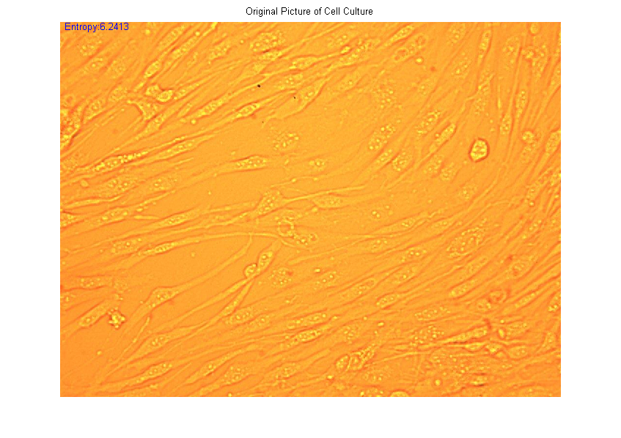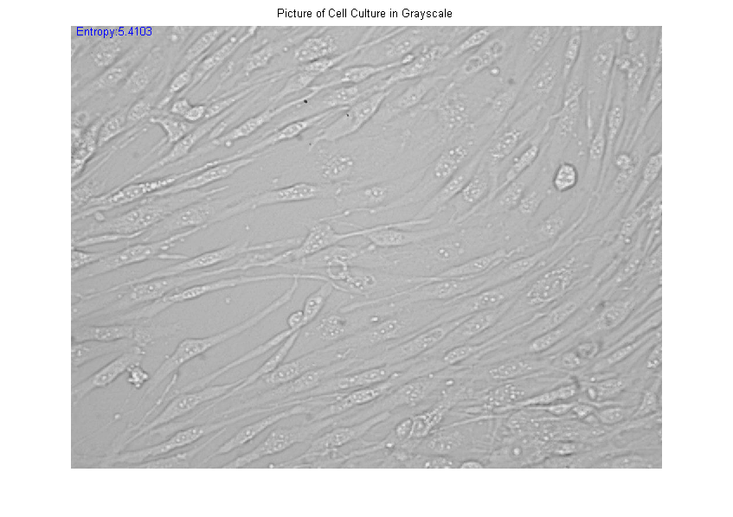Bovine Endothelial Cell Sample #1

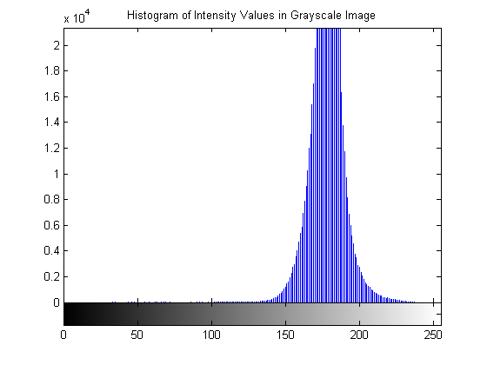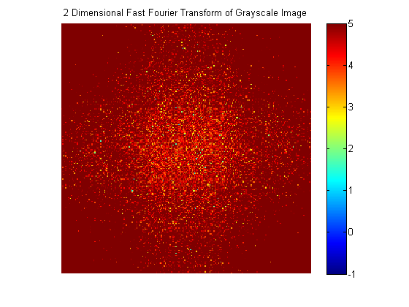

Bovine Endothelial Cell Sample #2

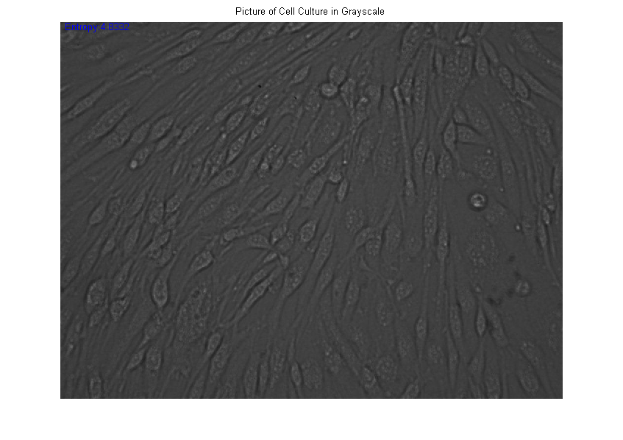

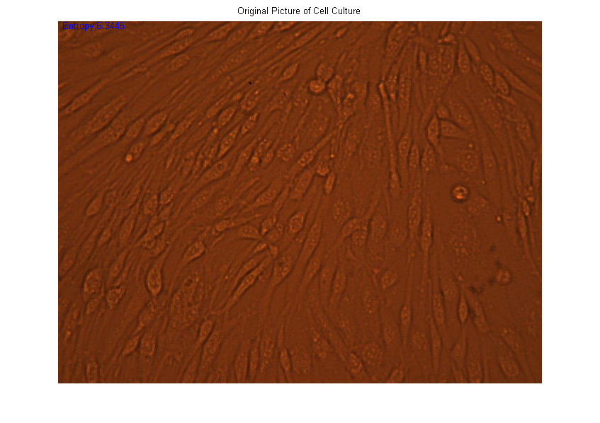

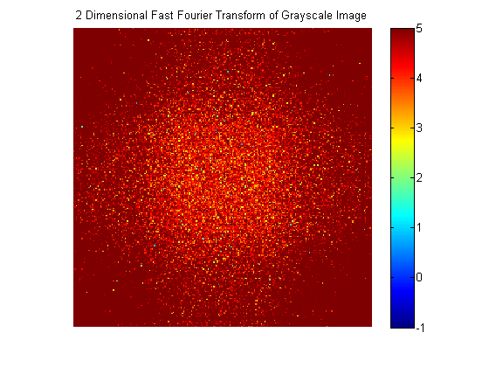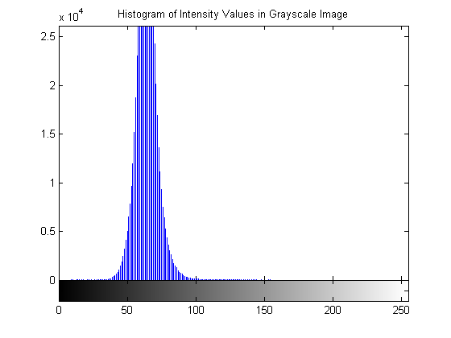

Bovine Endothelial Cell Sample #3

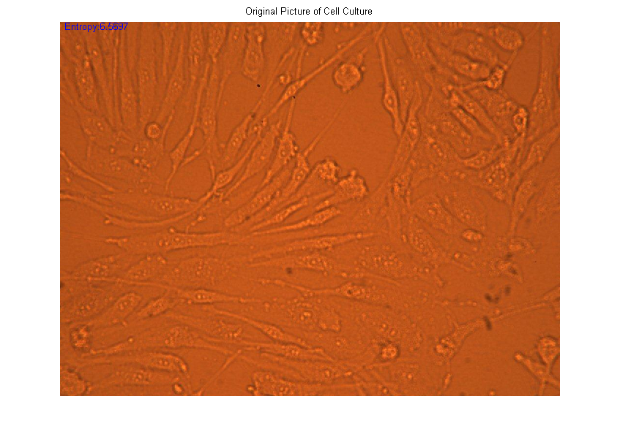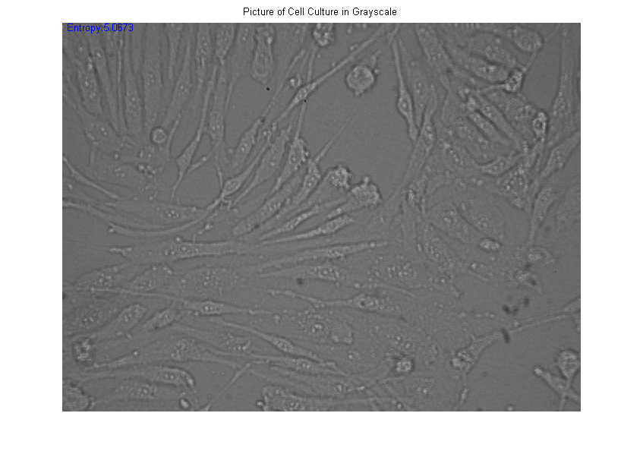

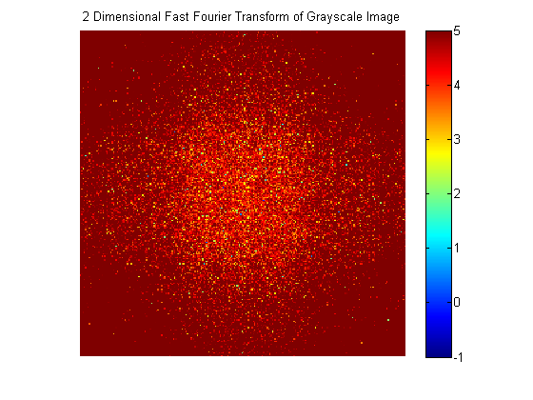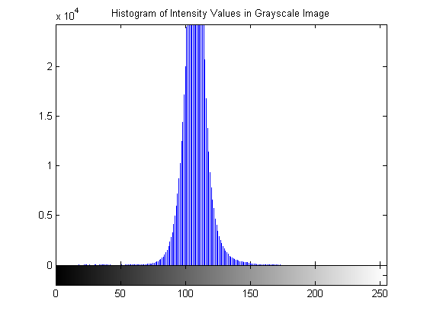

Bovine Aortic Endothelial Cell Sample #1

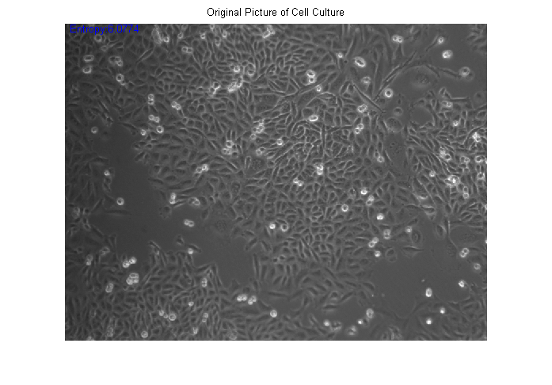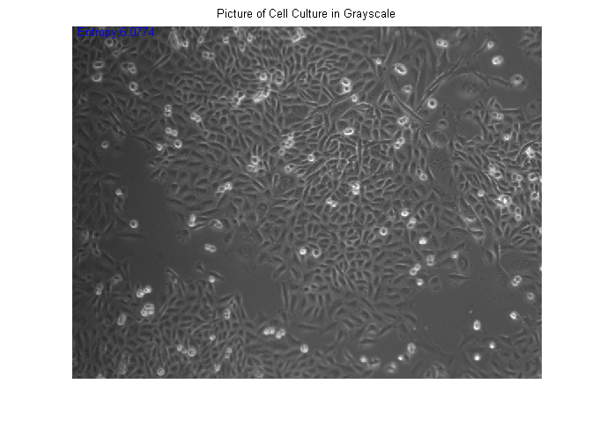

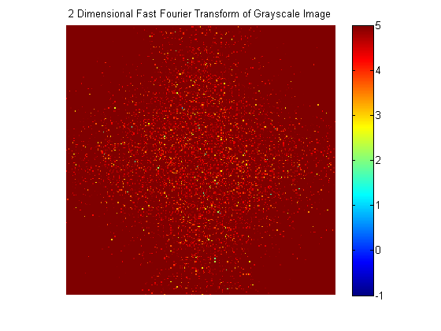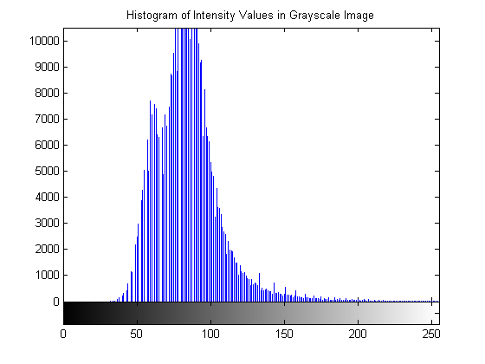

Bovine Aortic Endothelial Cell Sample #2

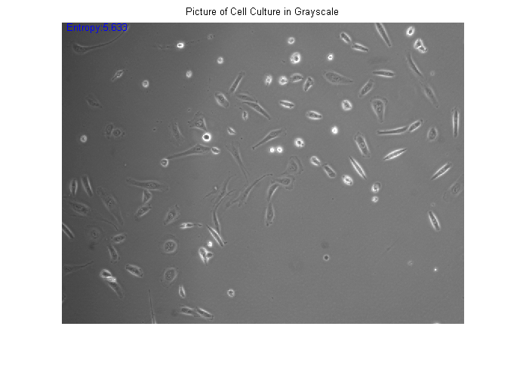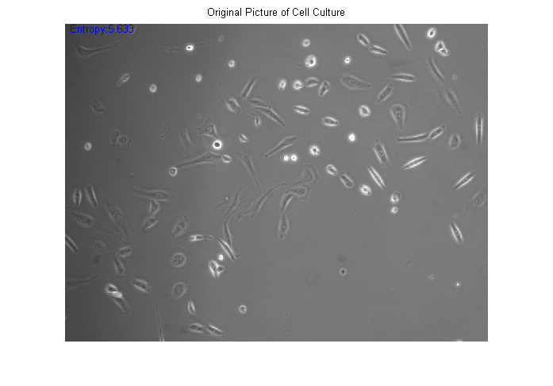

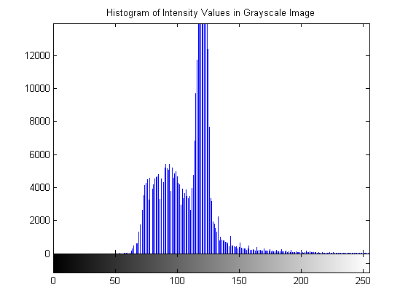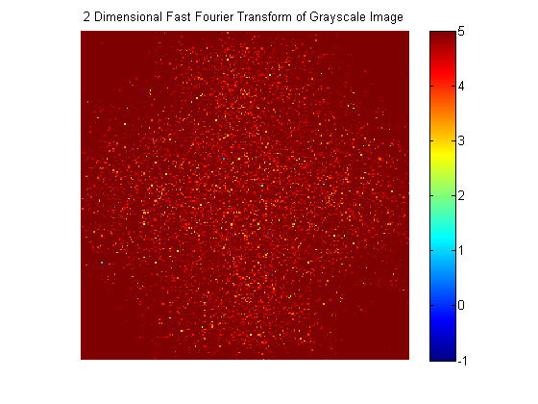

Bovine Aortic Endothelial Cell Sample #3

